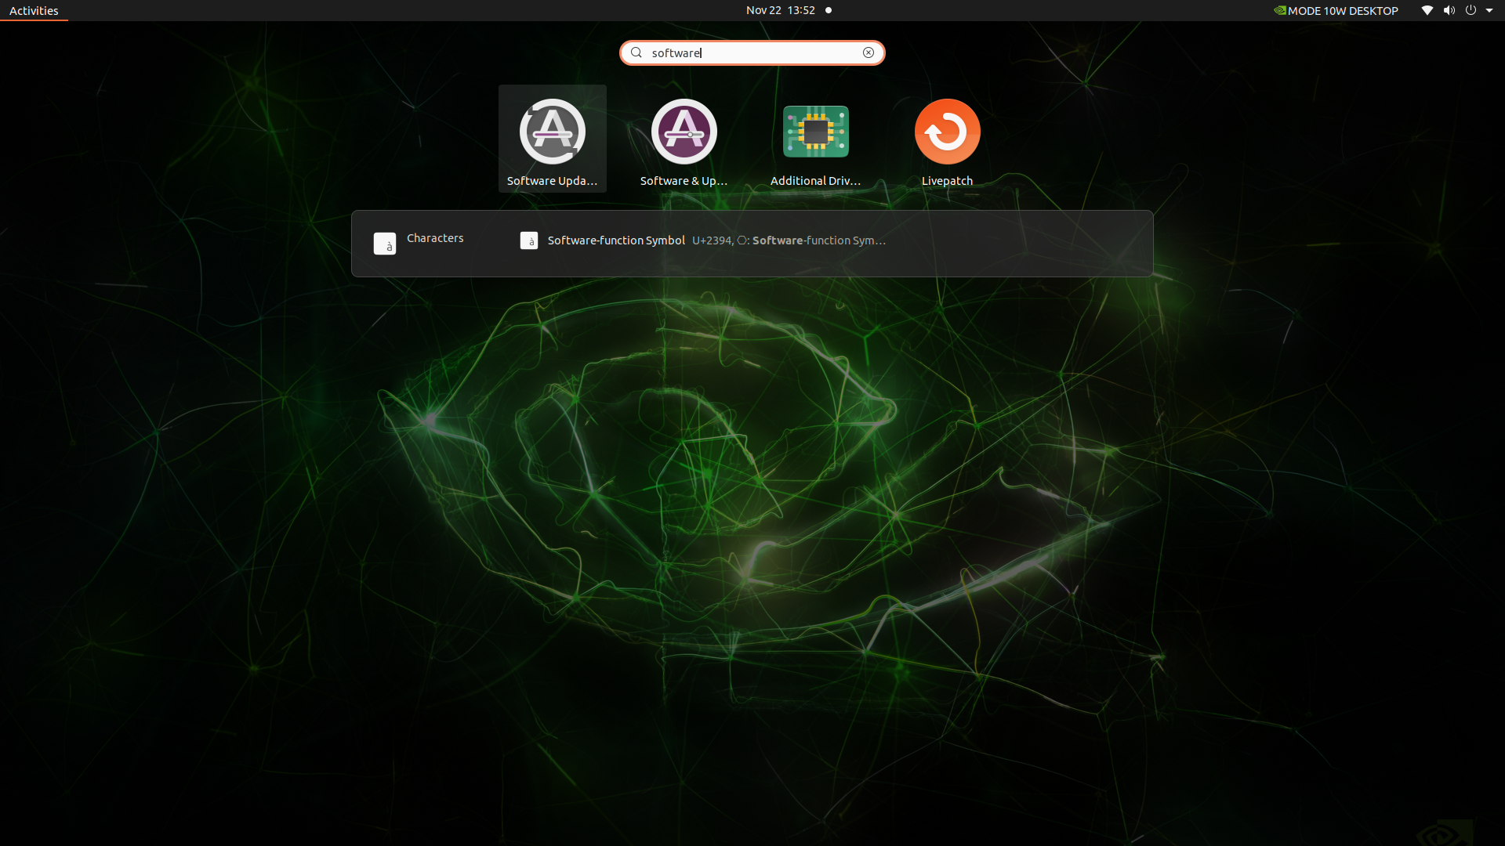

* Click on the software update grey color icon and let the system update itself.
* sudo apt update
* sudo apt install nvidia-jetpack
* sudo apt install pip
* cd Desktop/
* python3 -m pip install --upgrade pip
* python3 -m pip install virtualenv
* python3 -m virtualenv low_lying
* source low_lying/bin/activate
* Pip3 install -r requirements.txt
* Pip3 uninstall torch
* Download the wheel file for pytorch from the link: <https://developer.download.nvidia.com/compute/redist/jp/v502/pytorch/torch-1.13.0a0+d0d6b1f2.nv22.10-cp38-cp38-linux_aarch64.whl>
* sudo apt-get install python3-pip libopenblas-base libopenmpi-dev libomp-dev
* pip3 install Cython
* Install the wheel file downloaded in the above steps
* Sudo apt install ./torch-1.13.0a0+d0d6b1f2.nv22.10-cp38-cp38-linux_aarch64.whl
* To install torchvision download the source file here: <https://github.com/pytorch/vision/archive/refs/tags/v0.13.0.tar.gz>
* Once downloaded extract the tar file

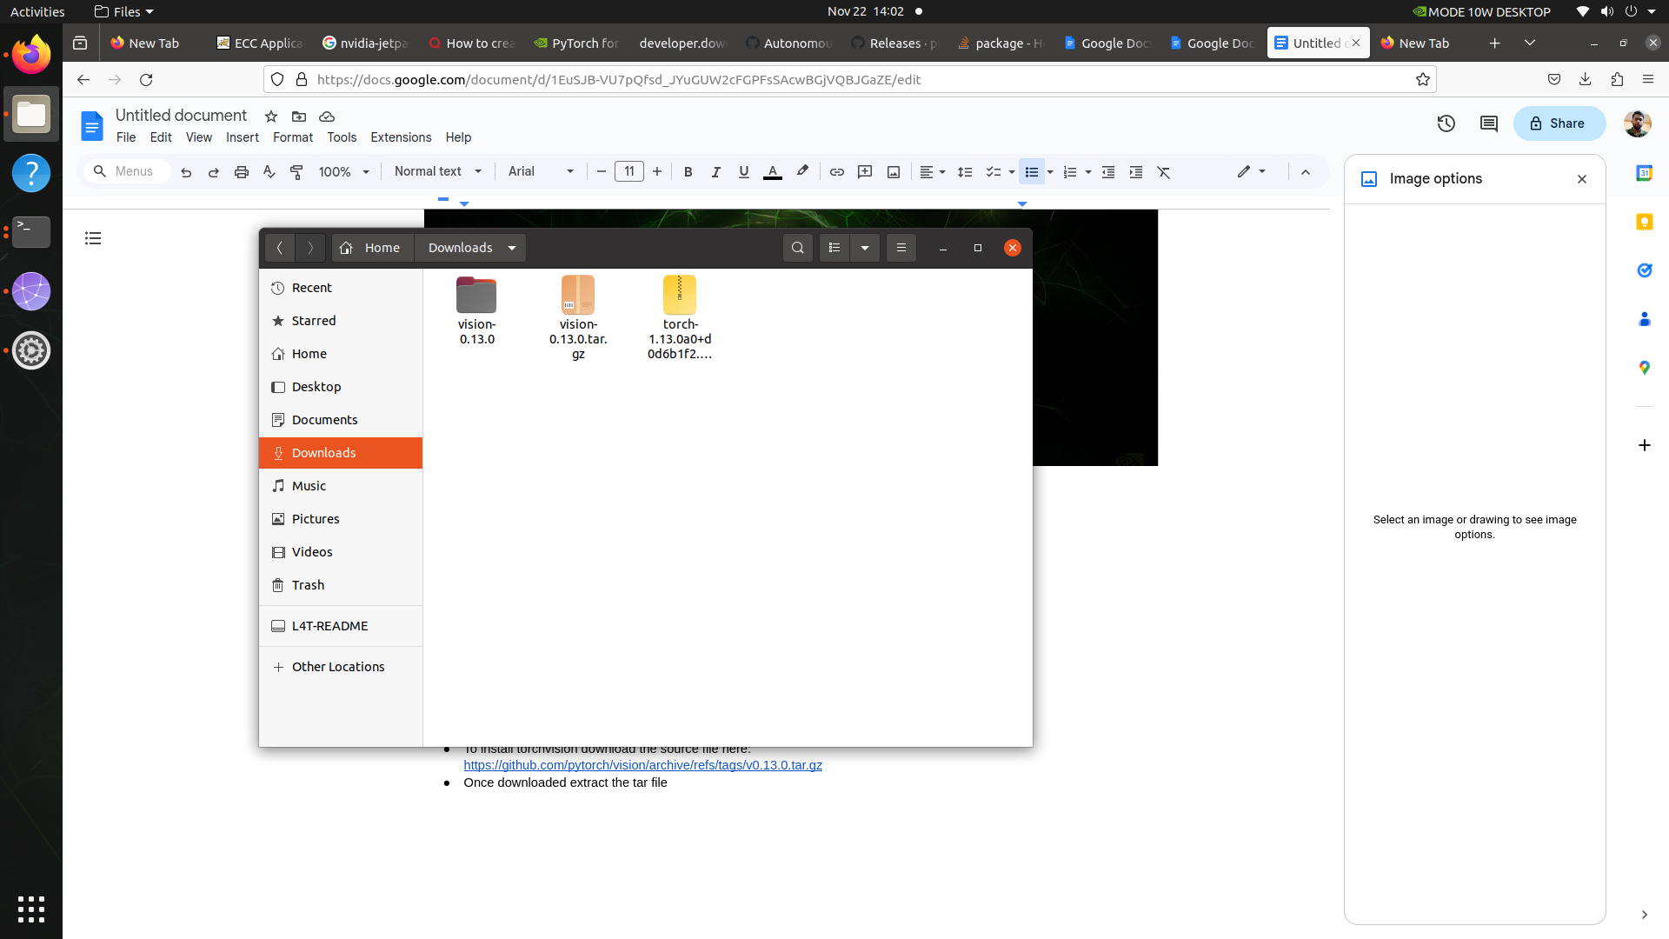

* Go inside extracted(vision -0.13.0) folder > torchvision > csrc > ops > quantized > cpu > qnms_kernel.cpp and comment the line 2 ( #include <ATen/native/quantized/affine_quantizer.h>)

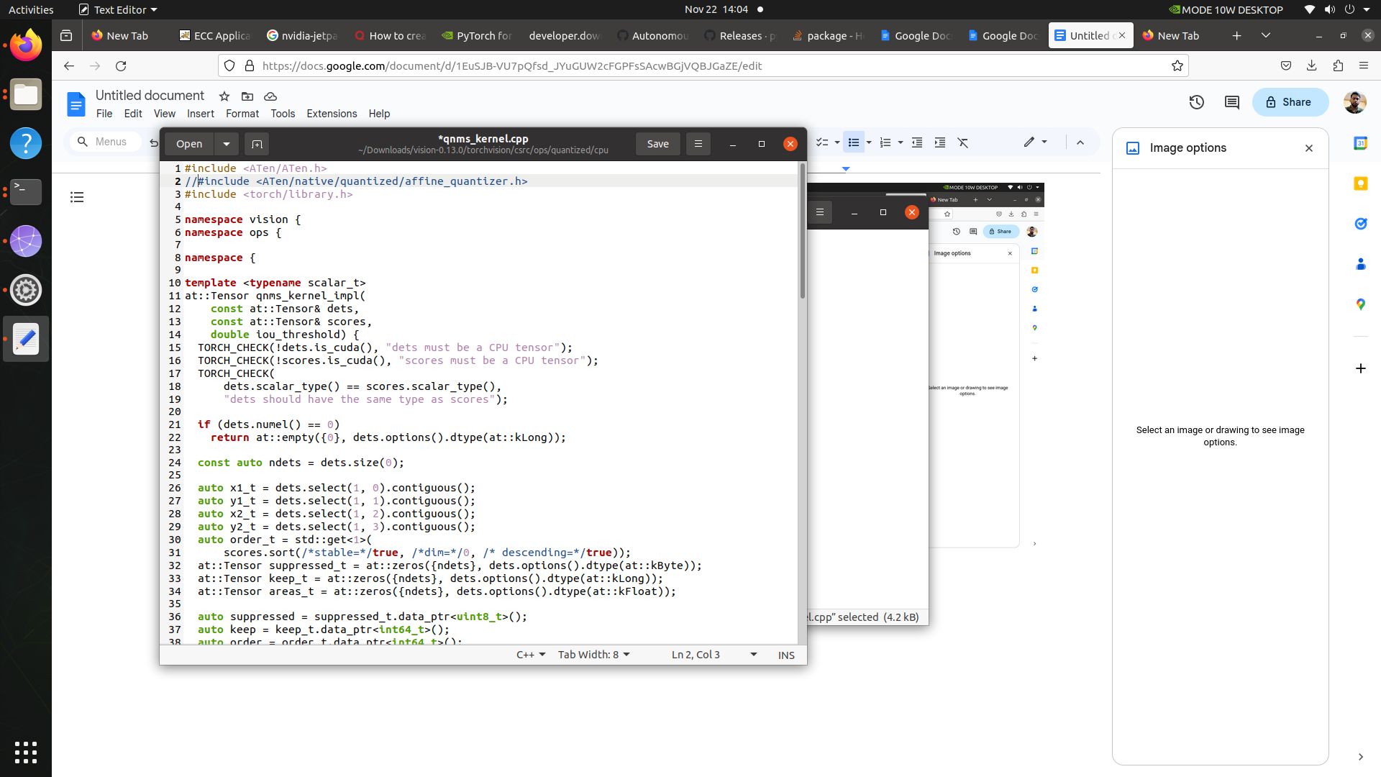

* cd ~/Downloads/vision-0.13.0/
* Run command: python setup.py install
* Make sure you are inside the virtual env and then run the realsense script: python realsense_camera.py